Answer for Exercise 5 (NG KE RONG 271063)

Task 1

1. What is the name to be given to this file?

Triangle.java

1. Compile this file. If you get any error, it means that you haven’t typed correctly the given codes.

No Error.

1. After a successful compilation, now try to run. Explain what happened and why.

No Output. Because there is no main method created that all operation method.

Task 2

1. Compile this file. If you get any error, it means that you haven’t typed correctly the given codes.

No Error.

1. After a successful compilation, now try to run. What’s the output?

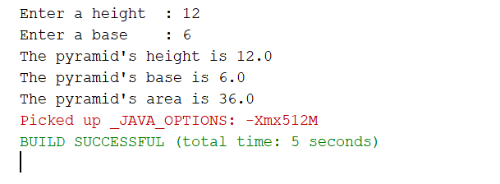

1. List ALL the following items based on the Triangle class:
2. object

tri

1. user-defined methods with return value

getHeight(), getBase(), getArea()

1. user-defined methods with passing-parameters

setHeight(double len), setBase(double b), set(double len, double b)

1. accessor methods

getHeight(), getBase(), getArea()

1. mutator methods

setHeight(double len), setBase(double b), set(double len, double b)